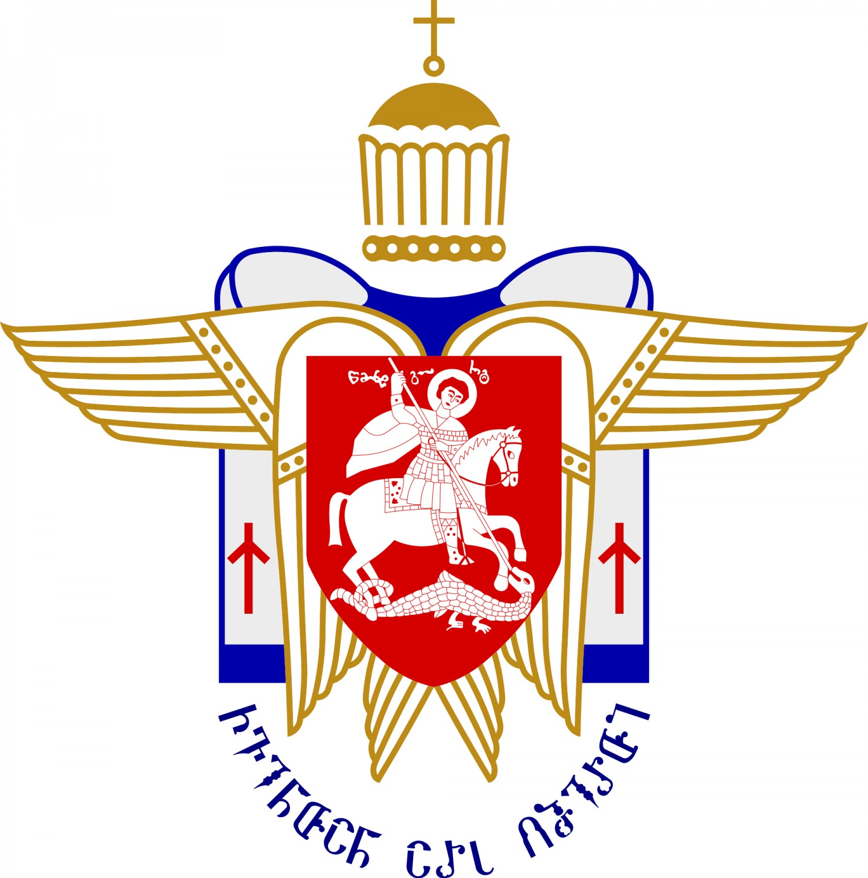
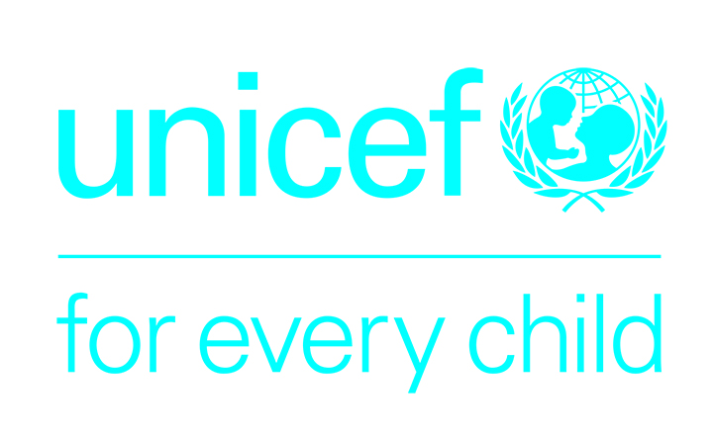

Memorandum of Understanding between Apostolic Autocephalous Orthodox Church of Georgia and the United Nations Children’s Fund

Memorandum of Understanding (MOU) between the Patriarchate of Georgia (hereinafter referred as Patriarchate) on the one part and the United Nations Children’s Fund (hereinafter referred as UNICEF) on the other part.

Purpose of this Memorandum of Understanding:

The Patriarchate of Georgia and UNICEF, taking in account the current situation in country, express their will to cooperate for numerous topics. For this purpose, the parties agree to cooperate to raise awareness of society in following areas:

- Protection of children from the violence and neglect.
- Improving care on the health of mothers and infants.
- Improving the services for vulnerable children, including those with disabilities.

In this regard, the Georgian Patriarchate and UNICEF will jointly implement numerous activities, in particular:

- Elaborate joint position and messages for protection of children from violence.
- Develop joint strategies and implement joint activities.
- Elaborate joint position and messages for improving services for pregnant women.
- With specific actions, address a high level of stigma against children with disabilities in the society.
- Advocate for the improvement of social services for children.

Forms of cooperation

The Patriarchate of Georgia and UNICEF are ready to exchange information on data and matters of common interest to the Parties and collaborate in the collection, analysis and distribution of such information and data, which is expressed as following involvement of parties:
- Georgian Patriarchate will ensure dissemination of jointly agreed messages to public
- UNICEF will ensure informing representatives of the Patriarchate in relation to the cooperation areas as well as contributing in the awareness rising of society.

The cooperation between the Parties as outlined in this MoU is not to be considered or construed as a partnership or other type of legal entity or personality. Nothing in this MoU shall be construed as superseding or interfering in any way with other agreements or contracts entered into between the Parties and/or any third parties. The Parties further specifically acknowledge that this MoU is not an obligation of funds, nor does it constitute a legally binding commitment by any Participant.

Authorized Representatives:

The Parties shall be represented by those holding or acting in the offices held by the signatories to this MoU.
Each Participant may, by written notice, to the other, identify additional representatives with certain authorization.
Each Participant shall notify the other, in writing, of changes in its authorized representatives.

On the Amendment and Modification of the MoU:

This MoU may be amended or modified by mutual written agreement of the Participants.

Entry into Force, Duration and Termination of the MoU

This MoU shall enter into force on the date of its signature by the Parties and shall remain in effect up to the 31 December 2019

The MoU may be terminated by either parties, by a 30 days advance justified notice to the other Party. Such termination shall take effect as of the date specified in the termination notice, provided that the provisions herein contained shall remain in effect to the extent necessary to permit an orderly settlement of all arrangements made with respect to the on-going cooperation activities.

This Memorandum of Understanding is prepared in Georgian and English in two copies. In the event of ambiguity or conflict between the two versions, the Georgian language version will prevail.

Georgian Patriarchate  Vicar of Patriarch of Georgia,  Mitropolit of Taoklarjeti and Lazeti | Teodore (Chuadze)
UNICEF Georgia  Representative | Laila Omar Gad

